Request Specification

given() returns a RequestSpecification — a builder object that accumulates everything about your request before it's sent.

HTTP request has several distinct components.

The 6 components of an HTTP request
1. Method — GET, POST, PUT, PATCH, DELETE, HEAD, OPTIONS
2. URL — base URI + path + path parameters + query parameters
3. Headers — metadata about the request (Content-Type, Accept, Authorization, custom)
4. Cookies — session state passed as HTTP cookies
5. Body — payload sent with POST / PUT / PATCH (JSON, XML, form data, binary)
6. Auth — credentials (covered in Phase 5)

URL Anatomy
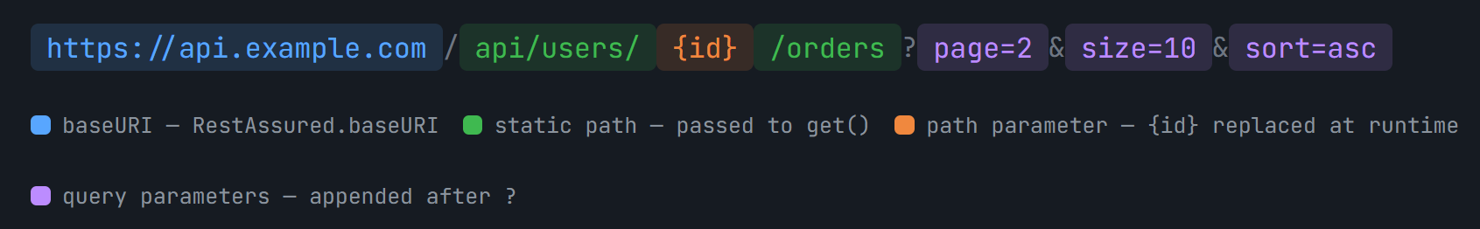
REST Assured assembles this URL internally from:

- baseURI
Set via RestAssured.baseURI = "https://api.example.com" or given().baseUri(...)
- basePath (optional)
A prefix appended after baseURI: RestAssured.basePath = "/api" — so you only write get("/users")
- Path with path parameters
The string passed to get("/users/{id}/orders") — placeholders {id} are replaced by pathParam("id", 42)
- Query parameters
Added with queryParam("page", 2) — REST Assured appends them after ? with proper URL encoding

Query Parameter
- appear after the ? in the URL and are used for filtering, pagination, sorting, and searching
- key-value pairs delimited by &
- do NOT change which resource is addressed — they modify how the resource is returned.

Example:

GET /api/users?page=2&size=10&sort=name&order=asc

still targets the /api/users resource, but asks for page 2, 10 items per page, sorted by name ascending

Ways to Pass Query Param.

- queryParam() — single param

// Adds ?page=2 to the URL
given()
.queryParam("page", 2)
.when()
.get("/api/users")
// Actual URL: GET https://reqres.in/api/users?page=2
.then()
.statusCode(200)
.body("page", equalTo(2));

- queryParam() — multiple params (chained)

// Adds ?page=1&size=5&sort=name&order=asc
given()
.queryParam("page", 1)
.queryParam("size", 5)
.queryParam("sort", "name")
.queryParam("order", "asc")
.when()
.get("/api/users")
.then()
.statusCode(200);

- queryParams() — pass a Map

// Build a map of all query params — useful when params come from data files
Map<String, Object> params = new HashMap<>();
params.put("page", 1);
params.put("size", 10);
params.put("sort", "email");
params.put("active",true);

given()
.queryParams(params) // note: queryParams (plural)
.when()
.get("/api/users")
.then()
.statusCode(200);

- Multi-value query params (same key, multiple values)

Some APIs accept the same key multiple times: /api/users?role=admin&role=manager. REST Assured handles this naturally.

// Produces: ?role=admin&role=manager&role=user
given()
.queryParam("role", "admin", "manager", "user") // varargs overload
.when()
.get("/api/users")
.then()
.statusCode(200);

Path Parameters

Path parameters are part of the URL path itself, enclosed in curly braces like {id}.
Identifies a specific resource, that is replaced by its value before sending request.

Ways to Pass Path Params

- Single path param

// {userId} in path is replaced with value 2
// Result: GET https://reqres.in/api/users/2
given()
.pathParam("userId", 2)
.when()
.get("/api/users/{userId}")
.then()
.statusCode(200)
.body("data.id", equalTo(2));

- Multiple path param

// Result: GET /api/users/5/orders/101
given()
.pathParam("userId", 5)
.pathParam("orderId", 101)
.when()
.get("/api/users/{userId}/orders/{orderId}")
.then()
.statusCode(200);

- Pass a Map

Map<String, Object> pathVars = new HashMap<>();
pathVars.put("userId", 5);
pathVars.put("orderId", 101);

given()
.pathParams(pathVars)
.when()
.get("/api/users/{userId}/orders/{orderId}")
.then()
.statusCode(200);

- Unnamed (positional) path params

If you pass the path parameter values directly into the URL method, REST Assured fills them positionally from left to right — no need to name them.

// Values 5 and 101 fill {0} and {1} positionally
// Result: GET /api/users/5/orders/101
given()
.when()
.get("/api/users/{0}/orders/{1}", 5, 101)
.then()
.statusCode(200);

Best Practice to always use named params as they are self deocumenting.

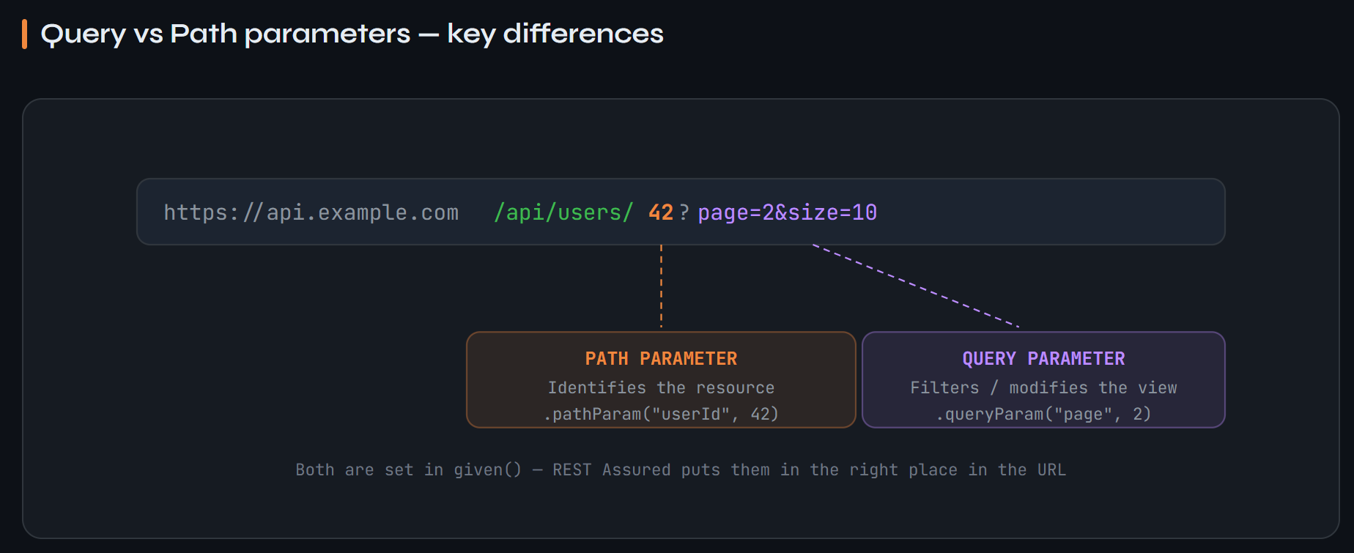

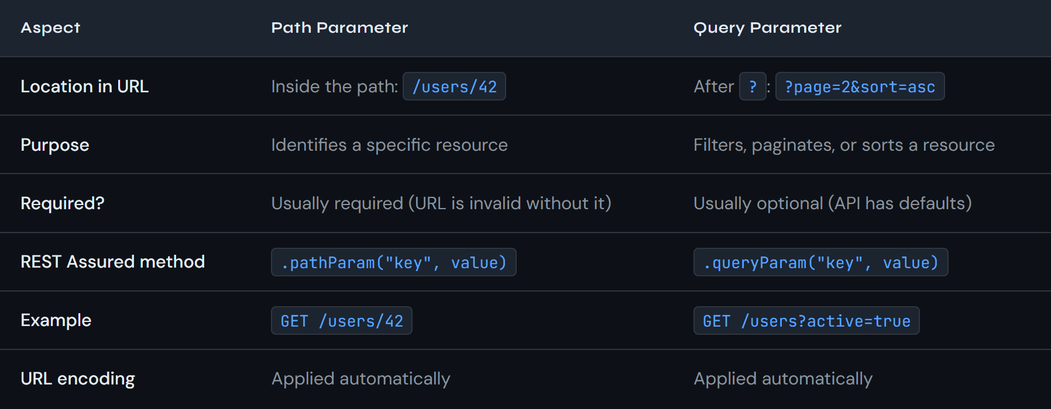

Headers
- HTTP headers are key-value metadata sent alongside a request.
- tell the server about the format of the request body, what response format the client expects, authentication tokens, client information, and more
- separate from the URL and Body.
- Lives in http packet header section.

Ways to Pass Header :
- Single header
given()
.header("Accept", "application/json") // tell server what format we want back
.header("Content-Type", "application/json") // tell server what format we're sending
.header("X-Request-ID", "abc-123") // custom header
.header("X-Api-Version","v2") // API versioning header
.when()
.get("/api/users")
.then()
.statusCode(200);

- Pass a Map or Header Object
// Via Map
Map<String, String> headersMap = new HashMap<>();
headersMap.put("Accept", "application/json");
headersMap.put("X-Correlation-ID","corr-456");
headersMap.put("X-Client", "test-automation");

given()
.headers(headersMap)
.when()
.get("/api/users")
.then()
.statusCode(200);

// Via REST Assured's Headers object (supports multiple values for same key)
import io.restassured.http.Headers;
import io.restassured.http.Header;

Headers headers = new Headers(
new Header("Accept", "application/json"),
new Header("Accept", "text/plain") // same key, two values
);

given()
.headers(headers)
.when()
.get("/api/users");

Content Type (shorthand methods)

Setting Content-Type is so common that REST Assured provides a dedicated shorthand using the ContentType enum instead of raw strings — reducing typos and improving readability.

import io.restassured.http.ContentType;

given()
.contentType(ContentType.JSON) // → Content-Type: application/json; charset=UTF-8

given()
.contentType(ContentType.XML) // → Content-Type: application/xml; charset=UTF-8

given()
.contentType(ContentType.TEXT) // → Content-Type: text/plain; charset=ISO-8859-1

given()
.contentType(ContentType.URLENC) // → application/x-www-form-urlencoded

given()
.contentType(ContentType.MULTIPART) // → multipart/form-data

given()
.contentType(ContentType.BINARY) // → application/octet-stream

// Or as raw string (less preferred):
given()
.contentType("application/json")

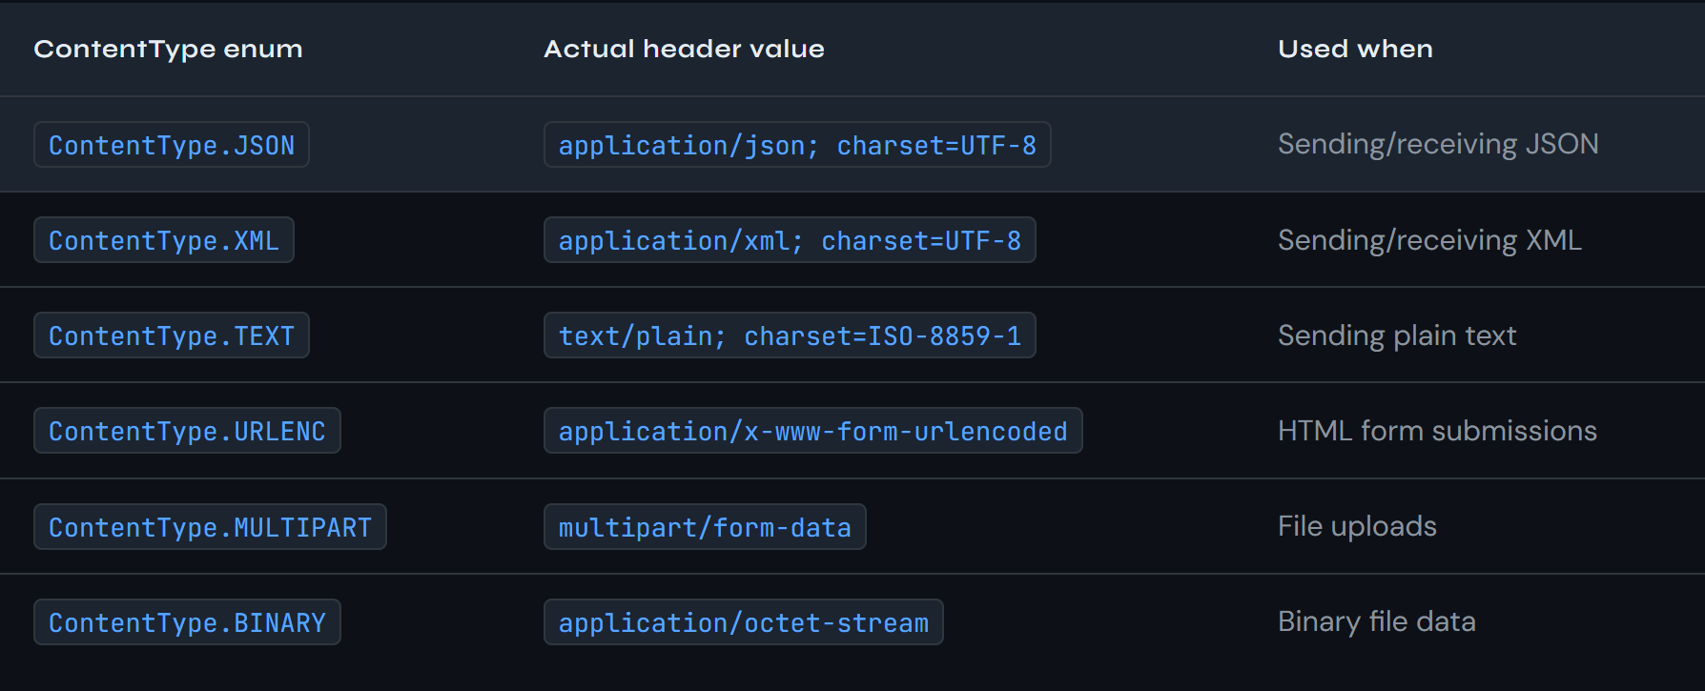

🔑 Content-Type vs Accept

These are the two most confused headers:
- Content-Type — describes the format of the request body you are sending.
- Accept — describes the format of the response you want to receive.
In most REST APIs, both are application/json. But they are logically different.

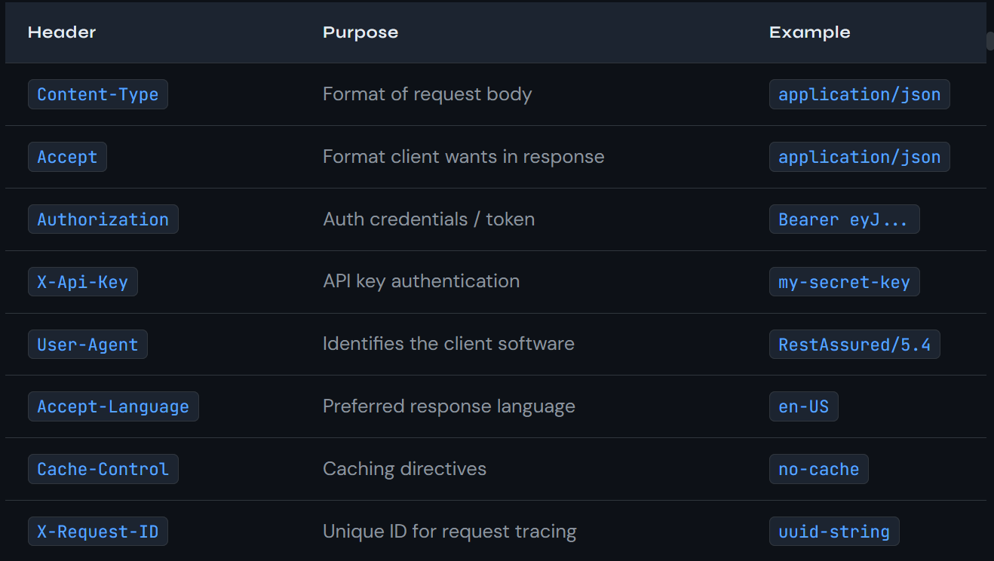

Cookies

Small piece of data stored by client and sent back to server with every request.
Commonly used for session management (ex – maintaining login state)

// Single cookie
given()
.cookie("sessionId", "abc-xyz-123")
.when()
.get("/api/dashboard")
.then()
.statusCode(200);
---------------------------------------------------------------------
// Multiple cookies
given()
.cookie("sessionId", "abc-xyz-123")
.cookie("userId", "user-42")
.cookie("csrfToken", "token-val")
.when()
.post("/api/submit");

----------------------------------------------------------------------------
// Cookies via Map
Map<String, String> cookieMap = new HashMap<>();
cookieMap.put("sessionId", "abc-xyz-123");
cookieMap.put("prefs", "theme=dark");

given()
.cookies(cookieMap)
.when()
.get("/api/profile");
------------------------------------------------------------------------------
// Detailed cookie with metadata (path, domain, expiry)
import io.restassured.http.Cookie;

Cookie detailedCookie = new Cookie.Builder("sessionId", "abc-xyz-123")
.setPath("/")
.setDomain("api.example.com")
.setSecured(true)
.setHttpOnly(true)
.build();

given()
.cookie(detailedCookie)
.when()
.get("/api/profile");

Read Cookies from Response :
// Typical flow: login → get cookie → use cookie in next request

// Step 1: Login and capture the session cookie from response
Response loginResponse =
given()
.contentType(ContentType.JSON)
.body("{\"email\":\"eve@reqres.in\",\"password\":\"cityslicka\"}")
.when()
.post("/api/login");

// Extract cookie from response
String sessionCookie = loginResponse.getCookie("session");

// Step 2: Use cookie in subsequent request
given()
.cookie("session", sessionCookie)
.when()
.get("/api/dashboard")
.then()
.statusCode(200);

// Or get all cookies at once as a Map
Map<String, String> allCookies = loginResponse.getCookies();

Request Body

The request body carries the payload data you send to the server — used with POST (create), PUT (full update), and PATCH (partial update). GET and DELETE requests typically have no body.
REST Assured's .body() method accepts multiple types: raw strings, Java Maps, POJOs (serialized via Jackson/Gson), and file references. The Content-Type header must match the format of the body.

Types in which body is passed :
- Body as raw string
JSON directly as a string literal, not recommended for large or complex payloads.
String requestBody = "{"
+ "\"name\": \"John Doe\","
+ "\"job\": \"Software Engineer\""
+ "}";

// Or using a text block (Java 15+)
String requestBody = """
{
"name": "John Doe",
"job": "Software Engineer"
}
""";

given()
.contentType(ContentType.JSON) // MUST set this with a body
.body(requestBody)
.when()
.post("/api/users")
.then()
.statusCode(201)
.body("name", equalTo("John Doe"))
.body("id", notNullValue());

Note : Raw JSON strings in Java require escaping every quote with \", becomes unreadable.

- Body as a Map
Pass a Map<String, Object> directly to .body(). REST Assured serializes it to JSON automatically using Jackson (when ContentType.JSON is set).
import java.util.HashMap;
import java.util.Map;

// Build request body as a Map
Map<String, Object> body = new HashMap<>();
body.put("name", "John Doe");
body.put("job", "Software Engineer");
body.put("age", 28);
body.put("active", true);

// Jackson serializes this Map to:
// {"name":"John Doe","job":"Software Engineer","age":28,"active":true}
given()
.contentType(ContentType.JSON)
.body(body)
.when()
.post("/api/users")
.then()
.statusCode(201)
.body("name", equalTo("John Doe"));

// Nested objects — use another Map as value
Map<String, Object> address = new HashMap<>();
address.put("city", "Hyderabad");
address.put("pincode","500001");

Map<String, Object> user = new HashMap<>();
user.put("name", "Ritik");
user.put("address", address); // nested object

// Produces: {"name":"Ritik","address":{"city":"Hyderabad","pincode":"500001"}}

- Body as a POJO

cleanest and most maintainable approach for a real framework.
Create a Java class (POJO) representing your request model, set its fields, and pass the object directly.

This is type-safe, refactorable, and reusable.

package com.epam.campus.api.models;

import com.fasterxml.jackson.annotation.JsonInclude;

// @JsonInclude — skip null fields during serialization
@JsonInclude(JsonInclude.Include.NON_NULL)
public class UserRequest {

private String name;
private String job;

// ── Constructors ────────────────────────────────
public UserRequest() {}

public UserRequest(String name, String job) {
this.name = name;
this.job = job;
}

// ── Getters and Setters ─────────────────────────
public String getName() { return name; }
public void setName(String name) { this.name = name; }
public String getJob() { return job; }
public void setJob(String job) { this.job = job; }
}

-------------------------------------------------------------------------------------------------
// Create POJO instance
UserRequest newUser = new UserRequest("John Doe", "Software Engineer");

// Jackson converts it to: {"name":"John Doe","job":"Software Engineer"}
given()
.contentType(ContentType.JSON)
.body(newUser) // Jackson serializes the POJO
.when()
.post("/api/users")
.then()
.statusCode(201)
.body("name", equalTo("John Doe"))
.body("job", equalTo("Software Engineer"))
.body("id", notNullValue()); // server assigns an ID

POJOs are refactorable — rename a field and IntelliJ updates all usages. They're type-safe — you get a compile error if you mistype a field name. They're reusable — use the same class in multiple tests. They're testable — you can unit test the POJO independently. Maps and strings lack all of these advantages.

- Body from a File
For very large or complex JSON payloads, store the request body in a .json file in src/test/resources and load it at runtime.
import java.io.File;

// File lives at: src/test/resources/payloads/create_user.json
File requestFile = new File("src/test/resources/payloads/create_user.json");

given()
.contentType(ContentType.JSON)
.body(requestFile)
.when()
.post("/api/users")
.then()
.statusCode(201);

HTTP Verbs — POST, PUT, PATCH, DELETE
- POST (Creates a Resource)

POST sends data to create a new resource.
server generates the resource's ID.
A successful POST typically returns 201 Created with the newly created resource in the response body.

- PUT (updates the full body)

PUT replaces entire resource with provided data.
If any field is missing, then the missing field gets removed or set to null/ default on the server.
PUT is idempotent — calling it multiple times produces the same result.
Java

- PATCH (Partial Update)

Updates only the field we send, field that are not sent remains unchanged on server.
PATCH is also idempotent in practice (though not mandated by the HTTP spec).

- DELETE (Removes a resource )

Removes the specified resource, return 204 No Content.

HEAD and OPTIONS
HEAD – identical to GET but the server returns only the headers, no body.
Used to check if a specific resource exists or not.
Ex – in the explore section of Instagram, all videos are not downloaded when we open a specific video, then only it gets download and we are able to watch.

OPTIONS – returns the HTTP Methods allowed on a resource.
Browsers send OPTIONS as a preflight request before a cross-origin (CORS) request.
My UseCase - verify the API's CORS configuration and allowed verbs.

// HEAD — check if resource exists without downloading body
@Test
public void testResourceExists() {
given()
.when()
.head("/api/users/2")
.then()
.statusCode(200) // exists
.header("Content-Type", containsString("json")); // header still present
}

// OPTIONS — check allowed methods on an endpoint
@Test
public void testAllowedMethods() {
given()
.when()
.options("/api/users")
.then()
.statusCode(200)
.header("Allow", containsString("GET"))
.header("Allow", containsString("POST"));
}

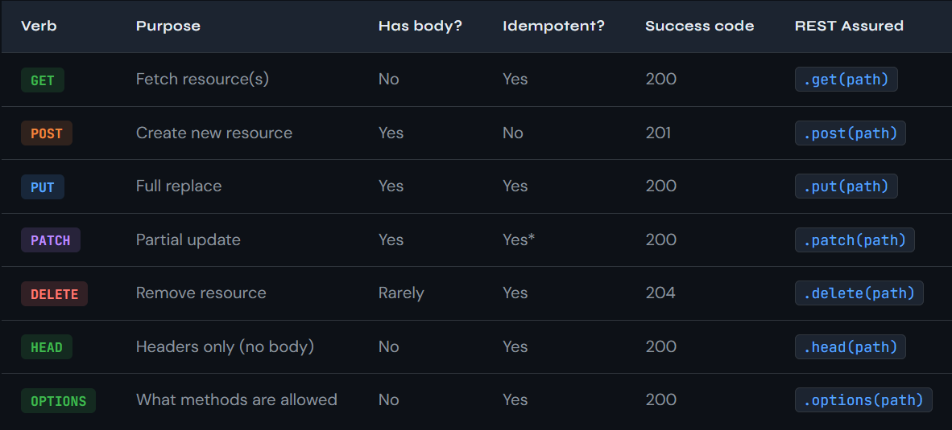

Form Parameters
- Form parameters are used when submitting data as an HTML form
- the body format is application/x-www-form-urlencoded, not JSON.
- Instead of JSON like {"email":"user@test.com"}, the body looks like email=user%40test.com&password=secret.
- This is common for login endpoints and traditional form-based APIs.
FormParam vs QueryParam
- Format for both is same, key diff. is query params go in URL after ? ,
- Form param go in request body with Content-Type: application/x-www-form-urlencoded
- They are structured differently.

Sample Code :
// POST with form params — Content-Type is set automatically to URLENC
@Test
public void testLoginWithFormParams() {
given()
.formParam("email", "eve.holt@reqres.in")
.formParam("password", "cityslicka")
// Content-Type: application/x-www-form-urlencoded is set automatically
.when()
.post("/api/login")
.then()
.statusCode(200)
.body("token", notNullValue());
}

// OR: explicitly set content type + use body string (equivalent)
given()
.contentType(ContentType.URLENC)
.formParam("username", "admin")
.formParam("password", "pass123")
.when()
.post("/api/auth");

// Multiple values for same key (checkbox group in HTML form)
given()
.formParam("interests", "java", "python", "testing")
.when()
.post("/api/profile");

param() — smart auto-routing

REST Assured has a generic param() method that automatically routes to queryParam() or formParam() based on the HTTP method being used. For GET → becomes query param; for POST → becomes form param.

Always use explicit queryParam() or formParam() rather than the generic param() — even though param() works correctly, it hides your intent and makes the test harder to read. Explicit is always better in test code.

Multipart File Upload

- Multipart requests are used to upload files (images, PDFs, CSVs, etc.) to an API.
- The body is split into multiple parts, each with its own headers — typically one part for the file binary data and one for metadata.
- Content-Type is set to multipart/form-data.

import java.io.File;

// ── Pattern 1: Upload file from disk ────────────────────────────
File uploadFile = new File("src/test/resources/files/sample.pdf");

given()
.multiPart(uploadFile) // uses filename as field name
.when()
.post("/api/documents/upload")
.then()
.statusCode(200)
.body("filename", equalTo("sample.pdf"));

// ── Pattern 2: Specify field name (form control name) ──────────
given()
.multiPart("file", uploadFile) // field name = "file"
.when()
.post("/api/documents/upload")
.then()
.statusCode(200);

// ── Pattern 3: Specify field name + MIME type ───────────────────
given()
.multiPart("avatar", uploadFile, "image/png")
.when()
.post("/api/users/2/avatar")
.then()
.statusCode(200);

// ── Pattern 4: File + metadata fields together ─────────────────
given()
.multiPart("file", uploadFile, "image/jpeg")
.multiPart("description", "Profile photo") // text metadata part
.multiPart("category", "avatar")
.when()
.post("/api/uploads")
.then()
.statusCode(200)
.body("status", equalTo("uploaded"));

// ── Pattern 5: Upload file from byte array (e.g., generated content) ─
byte[] fileBytes = "file content here".getBytes();

given()
.multiPart("file", "myfile.txt", fileBytes, "text/plain")
.when()
.post("/api/uploads")
.then()
.statusCode(200);

📝 Content-Type in multipart

You do not need to set contentType(ContentType.MULTIPART) manually when using multiPart() — REST Assured sets it automatically and also includes the required boundary value (e.g. multipart/form-data; boundary=----WebKitFormBoundary...). If you set it manually, you may override the boundary and break the request.

CONTENT_TYPE

The Content-Type header is what tells the server how to parse your request body. Getting it wrong results in 400 Bad Request or the server misinterpreting your data silently.

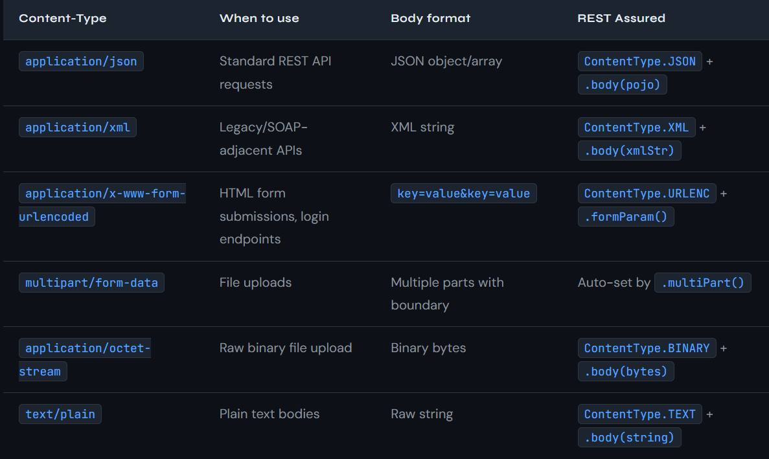

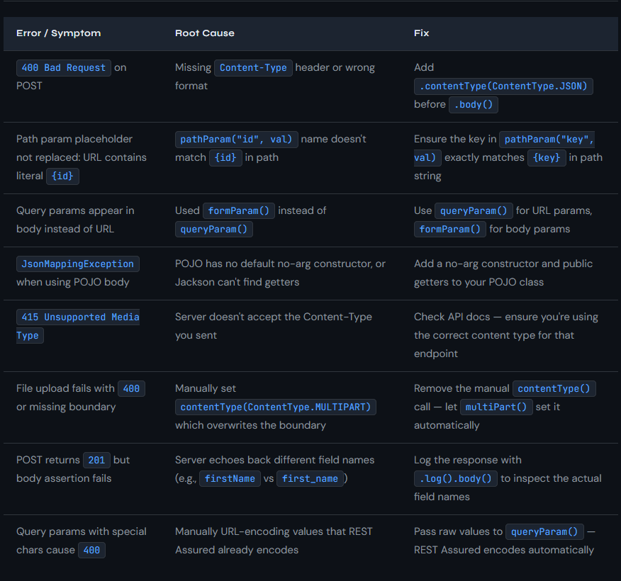

Questions

Q1 : Explain the difference between path parameters and query parameters and use both correctly

:: Both the path and query parameters are the part URL, path parameters is used t uniquely identify a resource and query parameters are appended at the end of the URL with ? and are used to filter, sort paginate or provide oprional modifications on already defined resource.

Q2 : Explain the difference between Content-Type and Accept headers ?

:: Content type in the headers defines Format in which we are sending the request And the Accept defines the format in which we are expecting the response from the server

